What can you find on the Commons?

If you look really carefully there are so many wonderful things living on our commons. How many different things can you find?

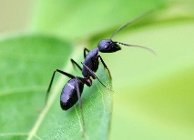Insects:

Ants Bees Wasps Spiders Shield Bugs

If you find any more draw a picture of them.

More Insects:

Worms Flies Hover Flies Centipedes

Can you find any more?

Butterflies

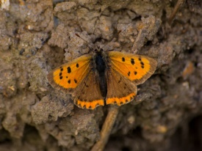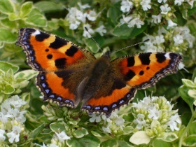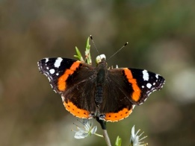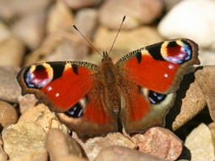

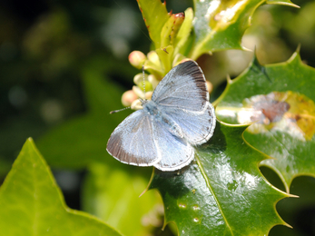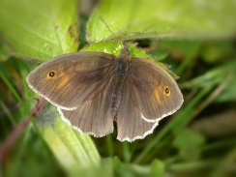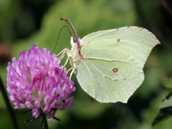Red Admiral Small Tortoiseshell Painted Lady Orange-tip

Brimstone Speckled Wood Common Blue Comma