What can you find on the Commons?

If you look really carefully there are so many wonderful things living in or near the ponds on our commons. How many different things can you find?

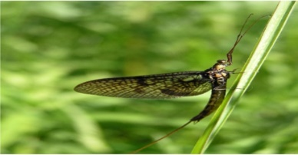Insects:

Emperor Dragonfly Mayfly Damselfly

Whirligig Beetle Mosquito Water slider or Pondskater

Can you find any more around the pond?

Insects you will find in the water:

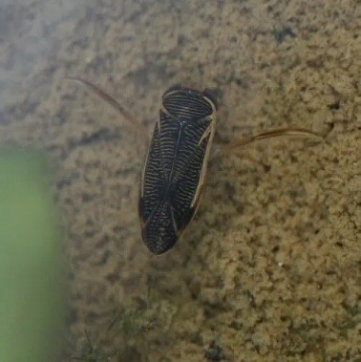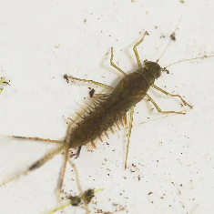

Mayfly larvae Dragonfly larvae Damselfly larvae Water Boatman

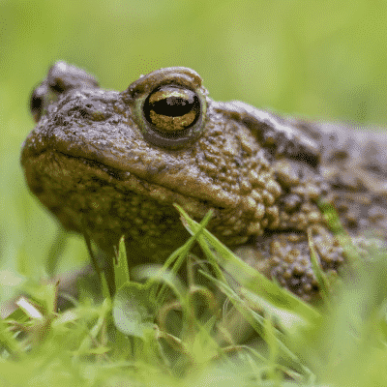 Other things to look for:

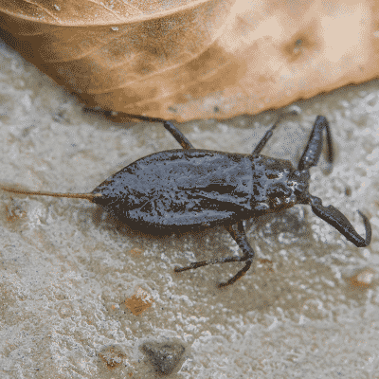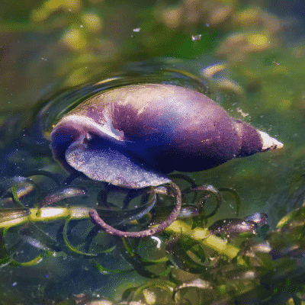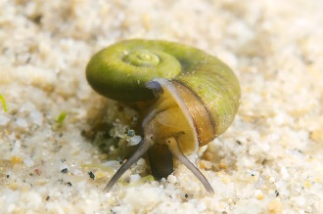

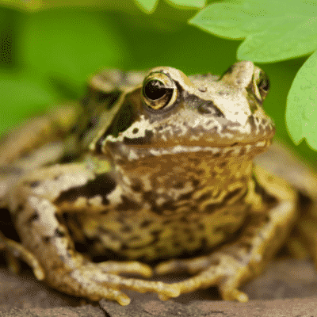Giant Ramshorn Snail Water snail Water scorpion Toads

Newts

Frogs Frog Spawn Tadpoles Crested

Newt