What can you find on the Commons?

If you look really carefully there are so many wonderful things living in or near the ponds and on our commons. How many different things can you find?

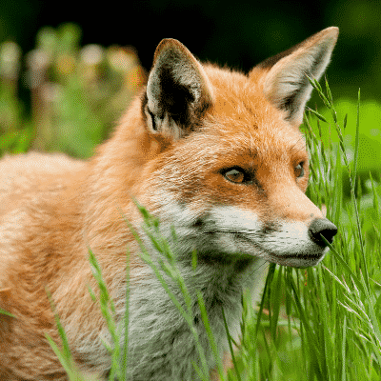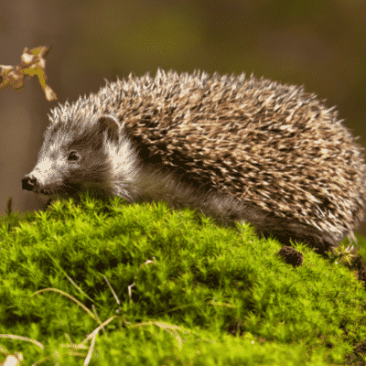

Grass snake Hedgehog Fox

Badgers Rats Grey Squirrels

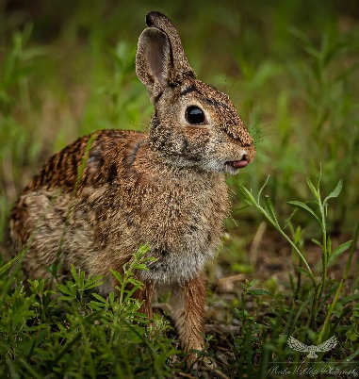

Rabbits Wood mouse Muntjac deer

Roe Deer Yellow necked Mouse Mole